Contact Improvisation Jam

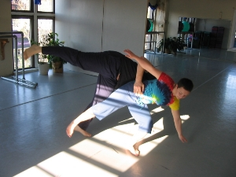
Sunday, April 6, 2008
3:30 Class
Trini Regaspi and Sean Cosgrove of the Pittsburgh Argentine
Tango Society (PATangoS), apply techniques from Nuevo
Argentine Tango to contact improv. Argentine tango is an
improvised social dance with the nuevo style emphasizing
creativity using natural partner dynamics. This class will
explore creative possibilities with the legs that can be
used in contact improv.
4:15-6 - Open Contact Jam

5824 Forbes Avenue, 3rd floor (in Squirrel Hill)
(Bodiography Dance Studio)
Pittsburgh, PA, 15217

Cost: $5

For beginners and experienced dancers
For more information, call Scott MacLeod at 412 478 0116
http://scottmacleod.com/contact.htm

Contact Improvisation Jam
Sunday, April 6, 2008

Trini Regaspi and Sean Cosgrove of the Pittsburgh Argentine
Tango Society (PATangoS), apply techniques from Nuevo
Argentine Tango to contact improv. Argentine tango is an
improvised social dance with the nuevo style emphasizing
creativity using natural partner dynamics. This class will
explore creative possibilities with the legs that can be
used in contact improv.

This work was pioneered in tango
by Pulpo (The Octopus) Esbrez with whom Trini & Sean have
studied for 3 years. Two videos of Pulpo’s work are
http://www.youtube.com/watch?v=OplUFeukicY
http://www.youtube.com/watch?v=WLgqRT6NGoE

Trini & Sean having been dancing Argentine Tango for over
12 years and teaching for seven, including at the Dance
Alloy, University of Pittsburgh and CMU. They use
Alexander Technique and contact improv to create an
intuitive approach to dancing that emphasizes partner
communication and musicality. More on Trini & Sean can be
found at http://home.comcast.net/~patangos/

