Contact Improvisational Dance Jam

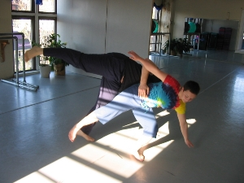

Sunday, August 5, 2007

3:30 Class with

Pete Boucher
Studied Contact Improvisation with Andrew Harwood, KJ Holmes, Nancy Stark Smith, Danny Lepkoff, Nina Martin, & Jennifer Keller; Was a company dancer for Bodiography Contemporary Ballet Company 2002-2005; Is a Stained Glass designer and painter.
4:15-6 - Open Contact Jam
5824 Forbes Avenue, 3rd floor (in Squirrel Hill)
(Bodiography Dance Studio)
Pittsburgh, PA, 15217

$5 suggested donation

For beginners and experienced dancers
For more information, call Scott MacLeod at 412 478 0116
http://scottmacleod.com/contact.htm

