Contact Improvisation Jam

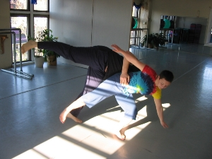
Sunday, June 1, 2008

3:30 Class
Contact Jam is in Bodiography Studio

Gustavo Lacerda began contact in Amsterdam, Holland. He enjoys engaging the improvisational process in multiple ways, including contact jams, as well as musically and theatrically.

Trini Regaspi and Sean Cosgrove substituted.

4:15-6 - Open Contact Jam

5824 Forbes Avenue, 3rd floor (in Squirrel Hill)
(Bodiography Dance Studio)
Pittsburgh, PA, 15217

Cost: $5

For beginners and experienced dancers
For more information, call Scott MacLeod at 412 478 0116
http://scottmacleod.com/contact.htm

