Contact Improvisation Jam

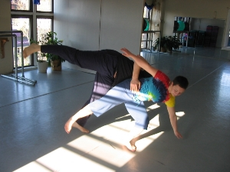
Sunday, May 4, 2008
3:30 Class
Jennifer Park began training and competing in gymnastics since the age of nine, then fell in love with and switched her passion to the ballet at the age of twelve. She studied dance at the Fine Arts Center in Willoughby, Ohio, and intensively at the Schools of Cleveland Ballet and Pittsburgh Ballet. Jennifer has performed professionally for the past eight years with Allied Motion, a modern dance company in residence at Penn State Altoona and has also been an instructor with Allied Motion's Children's Dance Theater. Jennifer is also an active choreographer and teaching artist in the Central Pennsylvania region, choreographing, performing and teaching Argentine Tango, modern dance, jazz, and ballet at local and statewide venues. She holds a BA in Psychology from Pittsburgh's Chatham University.

4:15-6 - Open Contact Jam

5824 Forbes Avenue, 3rd floor (in Squirrel Hill)
(Bodiography Dance Studio)
Pittsburgh, PA, 15217

Cost: $5

For beginners and experienced dancers
For more information, call Scott MacLeod at 412 478 0116
http://scottmacleod.com/contact.htm

