Contact Improvisational Dance Jam

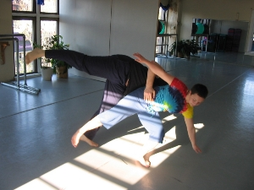

Sunday, October 7, 2007

3:30 Class with
Scott MacLeod
Scott studied modern dance with Reed College Dance Professor Judy Massee (Martha Graham) & improvisation in Pittsburgh with Pete Boucher (Contact); has taught Contact in Pennsylvania; has taught yoga, including partner work, for 9 years; teaches anthropology and sociology, esp. vis-a-vis the information technology revolution, as well as courses in Second Life.
4:15-6 - Open Contact Jam

5824 Forbes Avenue, 3rd floor (in Squirrel Hill)
(Bodiography Dance Studio)
Pittsburgh, PA, 15217

$5 suggested donation

For beginners and experienced dancers
For more information, call Scott MacLeod at 412 478 0116
http://scottmacleod.com/contact.htm

