Contact Improvisation Jam

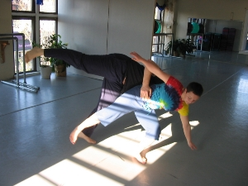
Sunday, September 7, 2008

3:30 Class
The Next Jam is September 7, 2008.

4:15-6 - Open Contact Jam

5824 Forbes Avenue, 3rd floor (in Squirrel Hill)
(Bodiography Dance Studio)
Pittsburgh, PA, 15217

Cost: $5

For beginners and experienced dancers
For more information, call Scott MacLeod at 412 478 0116
http://scottmacleod.com/contact.htm

